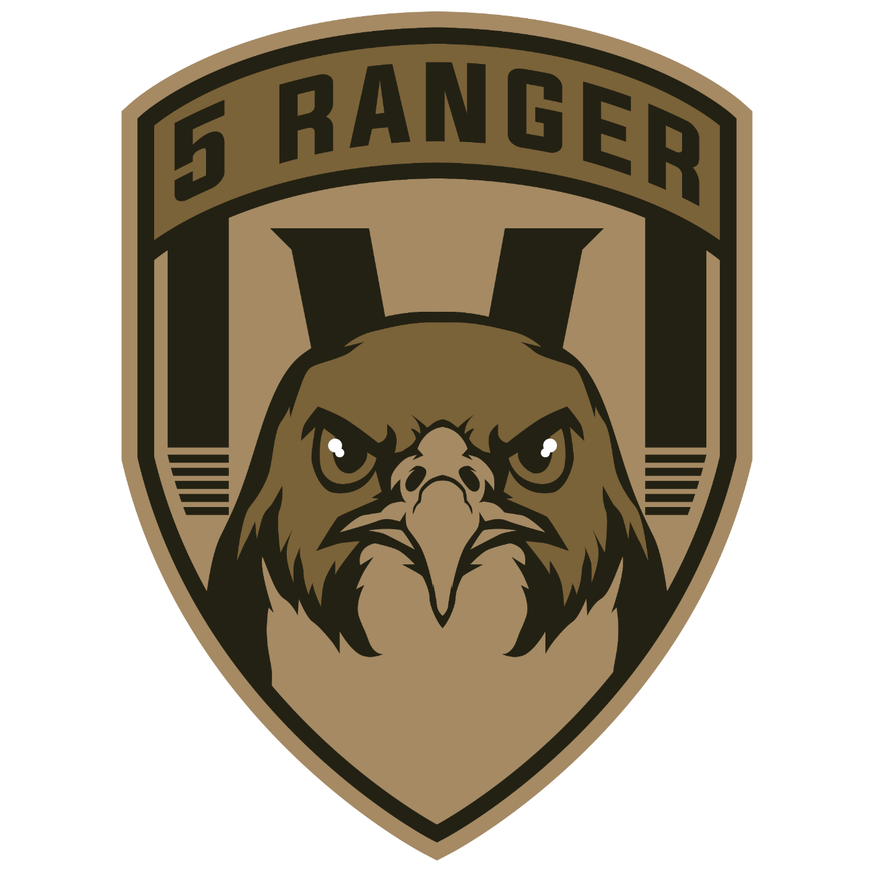

SHARPSHOOTER TRAINING GUIDE

Table of contents:
1. INTRODUCTION

2. WEAPON AND ADDONS

3. RANGING AND SCOPING

4. PRACTICAL

INTRODUCTION

Welcome to the sharpshooter cadre. This will focus on marksmanship and accuracy.
You will learn ranging, scoping and the usage of a sharpshooter rifle for long and short range engagements.
Make sure everyone has the regular sharpshooter loadout.
It must be emphasized that a sharpshooter is not a sniper and they will be picking out targets that the section itself is suppressing.

WEAPON AND ADDONS

Rifle - L129A1
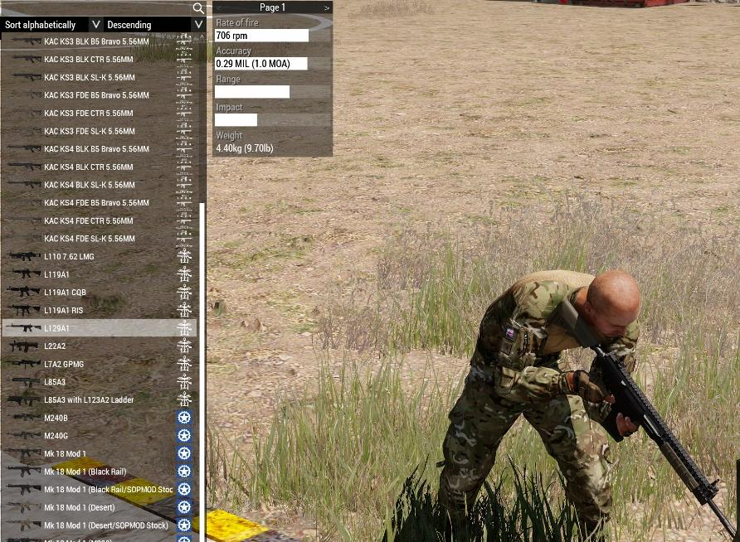

Scope – Trijicon ACOG TA648RMR-308

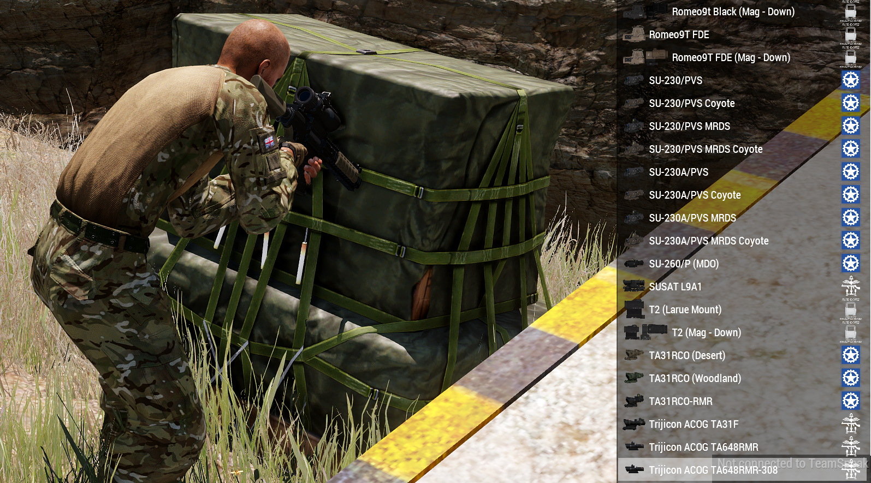
Night Vision Scope (available on issue from the platoon commander inside the night box in the logistics station)
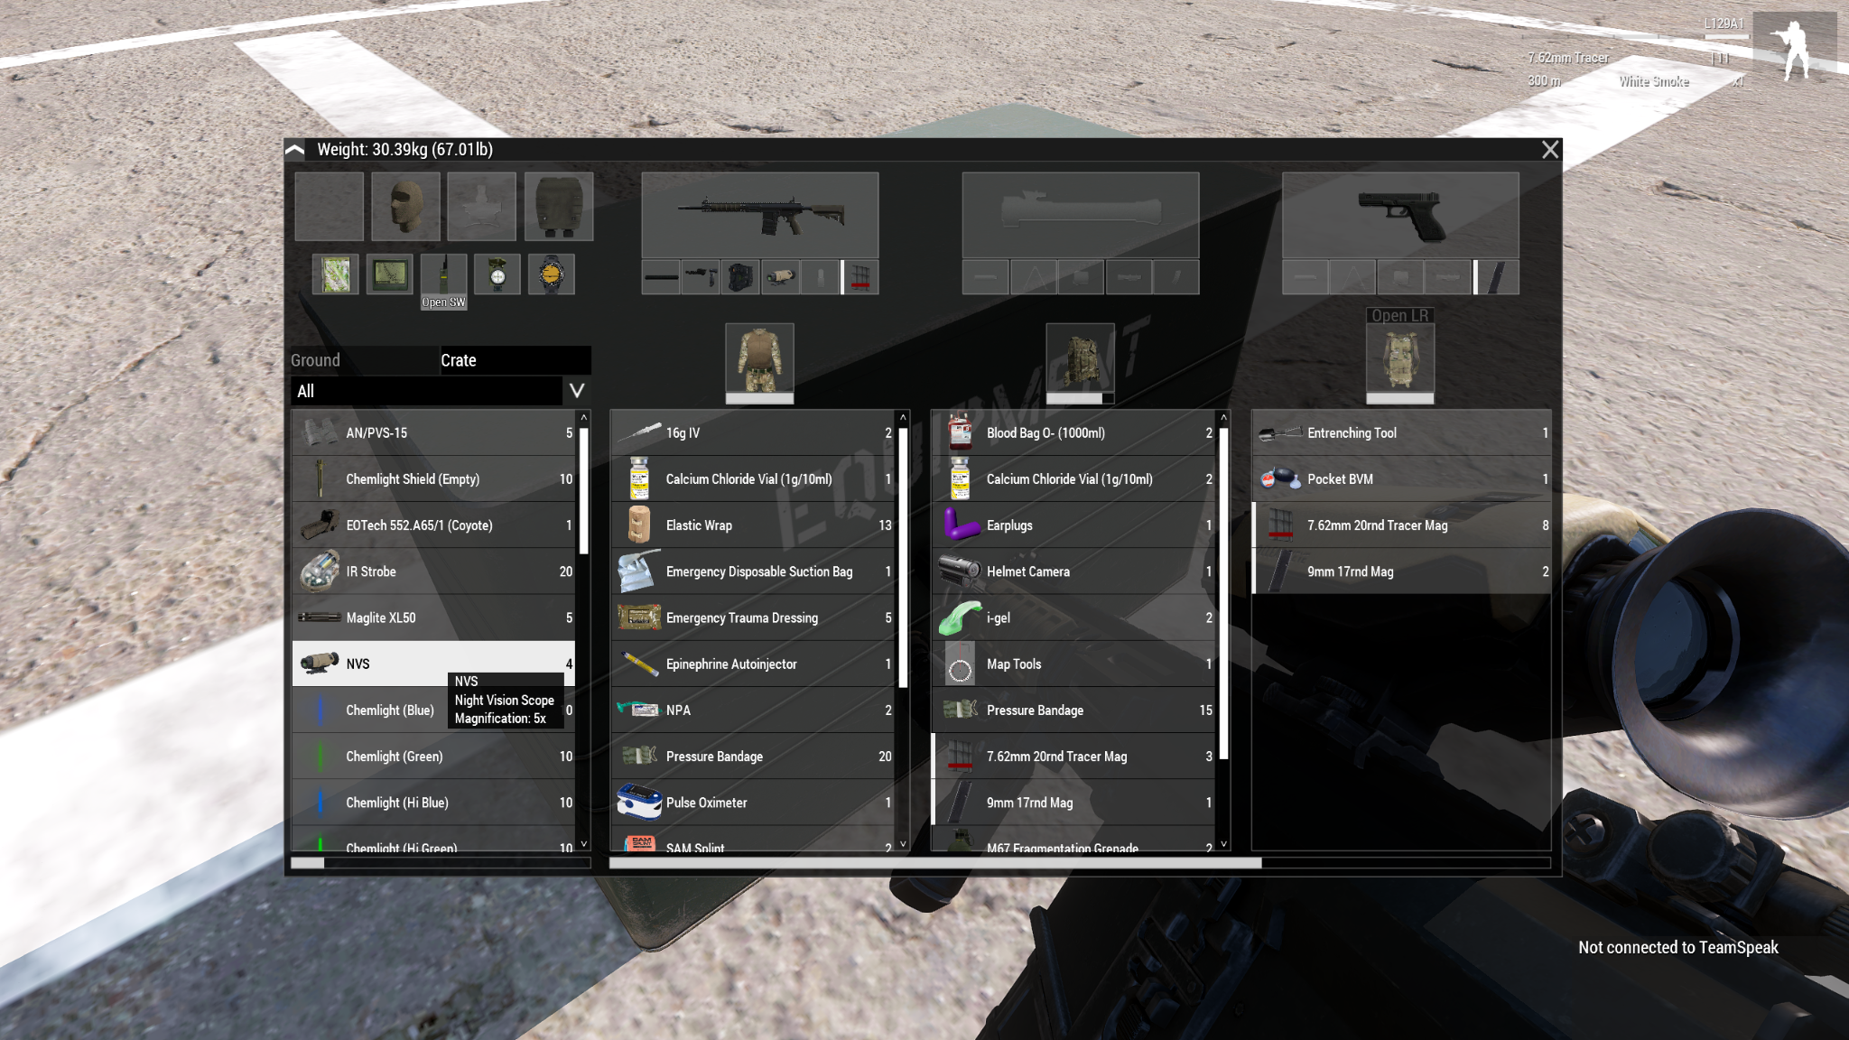

RANGING AND SCOPING

Ranging can be done by the sharpshooter themselves or by any section member willing to assist their sharpshooter using a rangefinder for accuracy.
Once the sharpshooter knows the distance to their target, they can scope them in by using the mildots in their scope to accurately place the trajectory of their shots.
Rangefinders should be used when a target is more than 400m away from the sharpshooter.
When ranging with the scope using the Trijicon ACOG TA648RMR-308 the shoulders of the objective should align with one of the horizontal lines in the scope.

Ranging Objective
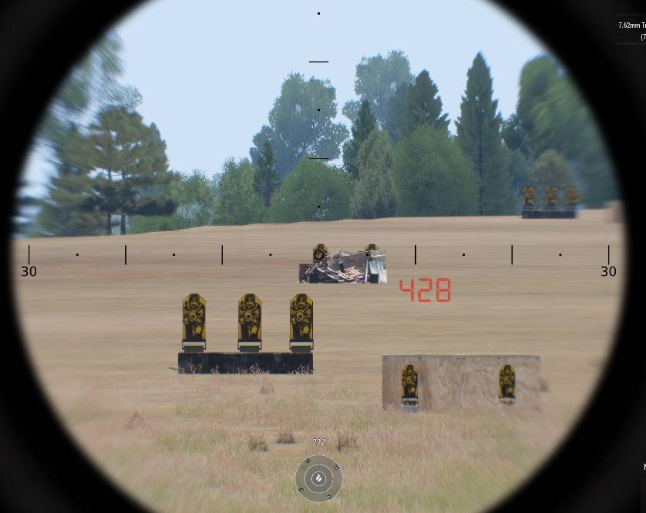

Scoping Objective
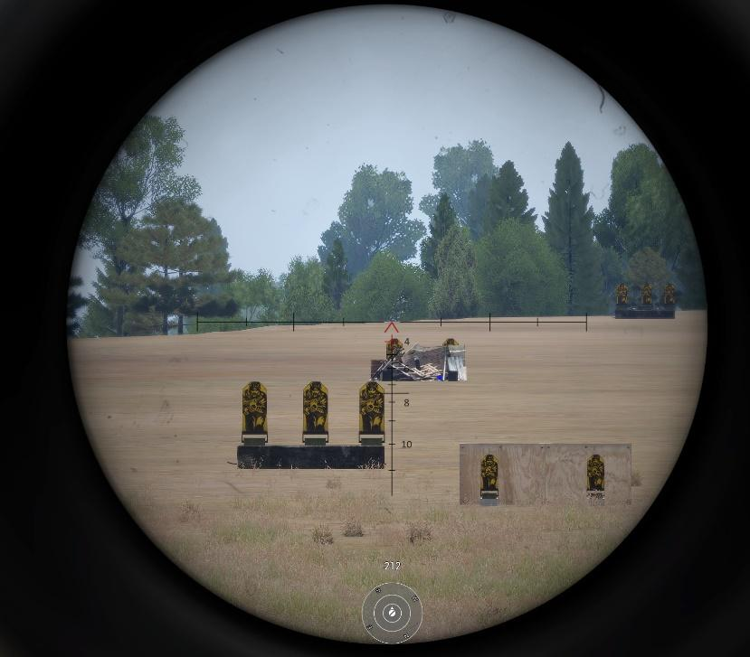

PRACTICAL

Once it’s understood how to recognize and take aim for the intended target it’s time for the trainee to test their ranging, scoping and firing skills with targets placed at different distances going from 100m to 800m.

Good communication is needed with their section to make sure the correct target is engaged and information is shared with the section in order to prevent mistakes being made.

Sharpshooter’s engagement should be deliberate and precise while working with the gunner to suppress and pin down the enemy and with the assistance of the 2IC to spot and range the enemy.

Priority targets when engaging enemies should be gunners from mobile or fixed platforms followed by drivers of vehicles, AT, MG, spotters and finally infantry.

